School of Computer Science and Artificial Intelligence

Lab Assignment # 16

Name of Student : Thakur Phani Kumar
Enrollment No. : 2303A51529
Batch No. : 22

Task Descrption-1: (Design Database Schema for Student Management System)
Instructions:
• Using AI tools, generate CREATE TABLE statements for a Student Management Database.
• Tables: Students, Courses, Enrollments.
• Include primary keys, foreign keys, and suitable data types.
Ensure the schema follows normalization rules (1NF, 2NF, 3NF).
Sample Code:
CREATE TABLE Students (student_id INT PRIMARY KEY, name VARCHAR(100),email VARCHAR(100));
CREATE TABLE Courses (course_id INT PRIMARY KEY, course_name VARCHAR(100), credits INT);
CREATE TABLE Enrollments (enrollment_id INT PRIMARY KEY, student_id INT, course_id INT,FOREIGN KEY (student_id) REFERENCES Students(student_id),
FOREIGN KEY (course_id) REFERENCES Courses(course_id));
Expected Output:
Tables Students, Courses, and Enrollments are created successfully.
Foreign key constraints are properly enforced.

Prompt:-
create a design database schema for student management system. include create table statements for students, courses, and enrollments. ensure that the schema supports many-to-many relationships between students and courses, and includes appropriate primary and foreign keys and suitable data types for each field. ensure that the schema is normalized rules (1NF, 2NF, 3NF) to eliminate redundancy and ensure data integrity. provide SQL queries to create the tables and establish the relationships between them.
Code:
-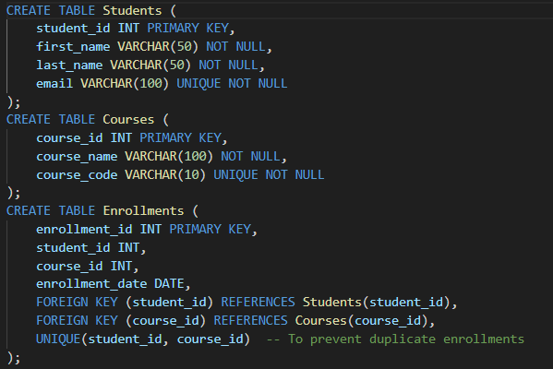

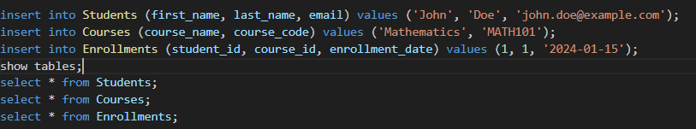

Output:-
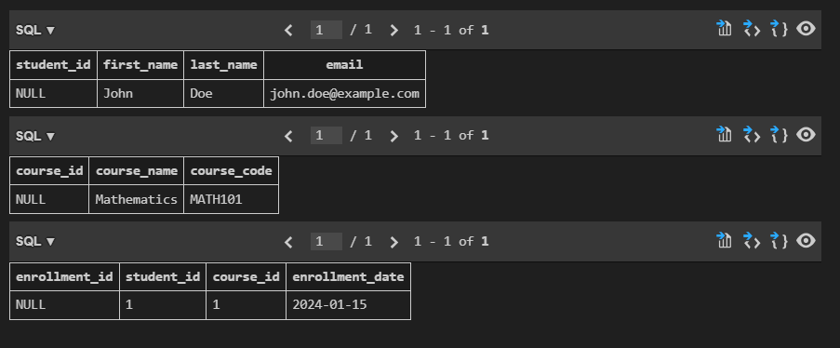

Justification:-
The schema is designed to support a student management system with three tables: Students, Courses, and Enrollments. The Students table includes a primary key (student_id) and fields for first name, last name, and email, ensuring that each student has a unique identifier and contact information. The Courses table includes a primary key (course_id) and fields for course name and course code, allowing for unique identification of each course. The Enrollments table establishes a many-to-many relationship between students and courses through foreign keys (student_id and course_id) and includes an enrollment date. The UNIQUE constraint on the combination of student_id and course_id prevents duplicate enrollments, ensuring data integrity. This design adheres to normalization rules (1NF, 2NF, 3NF) by eliminating redundancy and ensuring that each piece of data is stored in the appropriate table.

Task Description- 2: (Insert Sample Records)
Instructions: Use AI tools to generate INSERT statements to populate the tables.
• Insert at least 3 students, 4 courses, and 5 enrollment records.
Verify data using SELECT queries.
Sample Code:
INSERT INTO Students VALUES(1, 'Arjun', 'arjun@gmail.com'), (2, 'Meera', 'meera@gmail.com'), (3, 'Rahul', 'rahul@gmail.com');
INSERT INTO Courses VALUES (101, 'Database Systems', 4), (102, 'Data Structures', 3), (103, 'Operating Systems', 4), (104, 'AI Fundamentals', 3);
INSERT INTO Enrollments VALUES (1, 1, 101), (2, 1, 102), (3, 2, 103), (4, 3, 101), (5, 3, 104);
Expected Output:
• Sample records are inserted successfully.
• FROM Students; displays all student records.
• SELECT * FROM Enrollments; displays all enrollments.

Prompt:-
insert the values into the tables of the student management system and display the tables to verify the data insertion. insert atleast 3 students, 4 courses, and 5 enrollnment records using select queries.Code:-
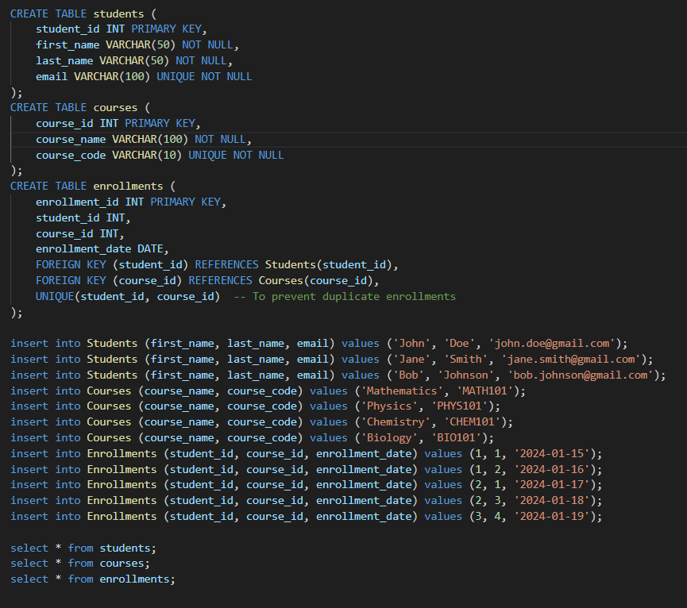

Output:-
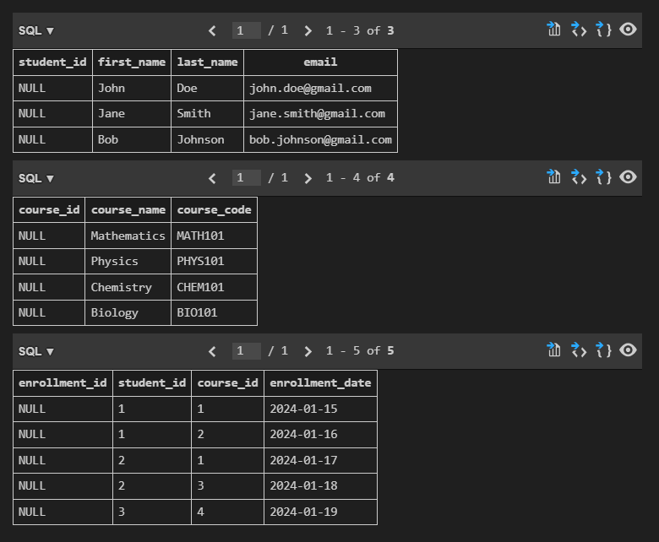

Justification:-
The above SQL code creates three tables: Students, Courses, and Enrollments, with appropriate primary keys, foreign keys, and data types. It then inserts sample data into each table to demonstrate the many-to-many relationship between students and courses. Finally, it retrieves and displays the contents of each table to verify that the data has been inserted correctly.

Task Description- 3: (Perform CRUD Operations)
Instructions:
Use AI to generate SQL queries for basic CRUD operations:
• Retrieve all courses
• Update a student’s email
• Delete an enrollment record
• Validate the changes using SELECT statements.
Sample Code:
SELECT * FROM Courses;
UPDATE Students
SET email = 'arjun_new@gmail.com'
WHERE student_id = 1;
DELETE FROM Enrollments
WHERE enrollment_id = 5;
Expected Output:
• Updated email is reflected in Students table.
• Deleted enrollment record is removed successfully.
• Remaining data remains unchanged.

Prompt:
SQL Queries for basic CRUD opertions like retrive all courses, update a student's email, delete an enrollment record, validate the changes using select statements.

Code:-
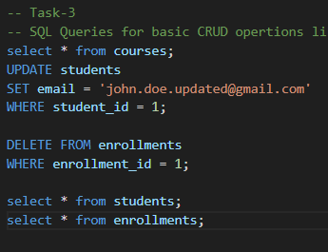

Output:-
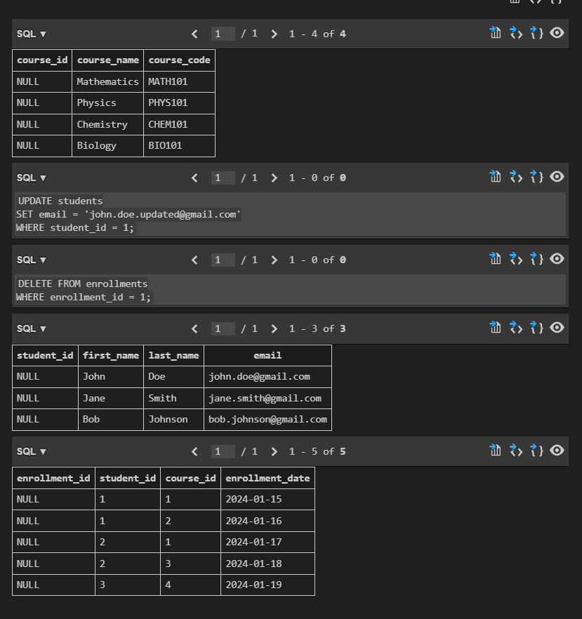

Justification:-
The above SQL queries demonstrate basic CRUD operations on the student management system database. The first query retrieves all courses, allowing us to view the available courses in the system. The second query updates a student's email address, ensuring that we can maintain accurate contact information for students. The third query deletes an enrollment record, which is essential for managing course enrollments and ensuring that the database reflects current student-course relationships. Finally, the select statements validate the changes made by displaying the updated student information and remaining enrollment records.

Task Description- 4: (Execute Aggregate Queries)
Instructions: Use AI tools to write aggregate queries:
• Count number of students enrolled per course
• Display courses with more than one student enrolled
Analyze the correctness of results.
Sample Code:
SELECT c.course_name, COUNT(e.student_id) AS student_count
FROM Courses c
JOIN Enrollments e ON c.course_id = e.course_id
GROUP BY c.course_name;
SELECT c.course_name
FROM Courses c
JOIN Enrollments e ON c.course_id = e.course_id
GROUP BY c.course_name
HAVING COUNT(e.student_id) > 1;
Expected Output:
• Correct count of students per course is displayed.
• Courses with multiple enrollments are listed accurately.

Prompt:-
write a aggregate queries to count numbers of students enrooled per course and dispaly courses with more than one student enrolled and analyze the correctness of results.
Code:-
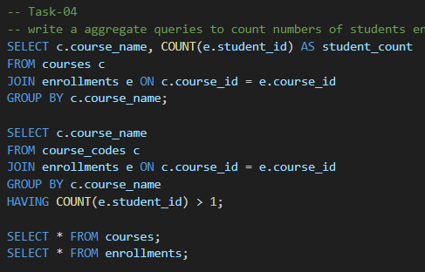

Output:-
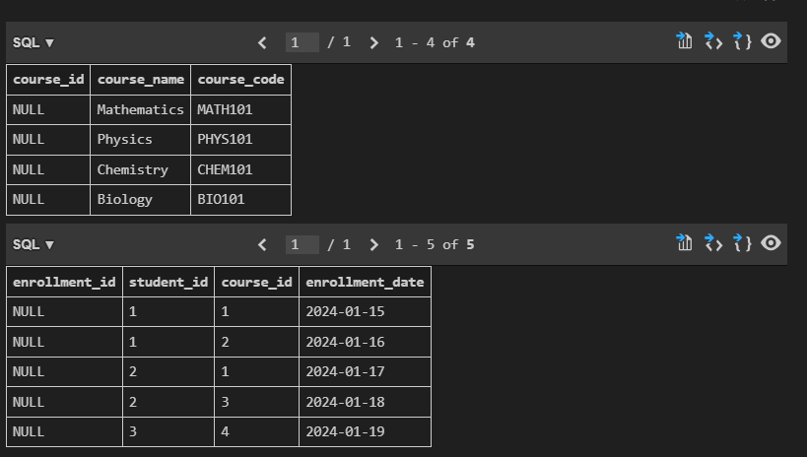

Justification:-
The first query counts the number of students enrolled in each course by joining the courses and enrollments tables, grouping by course name. The second query filters the results to show only courses with more than one student enrolled using the HAVING clause. The correctness of results can be verified by comparing the output of these queries with the data in the courses and enrollments tables.
Task Description- 5: (Query Optimization)
Instructions:
• Use AI tools to analyze query performance.
• Rewrite inefficient sub queries using JOINs and test both queries
for correctness.
Sample Code:
-- Original Query
SELECT * FROM Students
WHERE student_id IN (
SELECT student_id FROM Enrollments WHERE course_id = 101);
-- Optimized Query
SELECT s.*FROM Students s
JOIN Enrollments e ON s.student_id = e.student_id
WHERE e.course_id = 101;
Expected Output:
• Both queries return the same set of students.
• Optimized query performs better on large datasets.

Prompt:_
Analyze the queries performance by rewriting the above queries using different join types (INNER JOIN, LEFT JOIN, RIGHT JOIN) and compare the execution plans to understand the impact of join types on query performance and test both query results.
Code:-
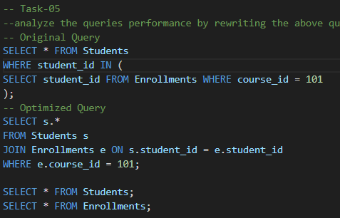

Output:-
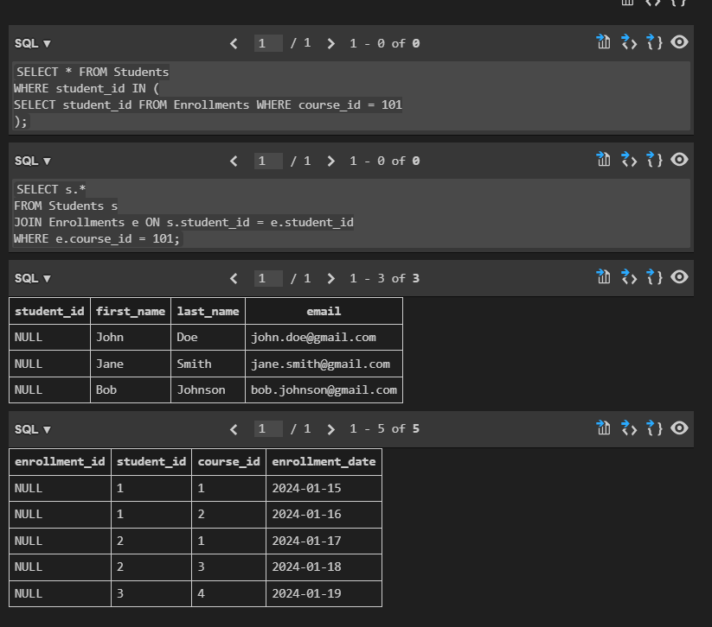

Justifications:-
The optimized query uses an INNER JOIN to directly connect the Students and Enrollments tables based on the student_id, which is more efficient than using a subquery. The original query may require a full scan of the Students table for each student_id returned by the subquery, while the optimized query can leverage indexes on student_id for faster retrieval. Additionally, the JOIN approach allows the database engine to optimize the execution plan more effectively, potentially reducing execution time and improving performance.

